1. 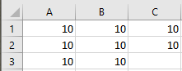

No interaction

1. 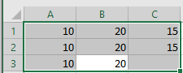

Yes main effect of A. No of B

1. 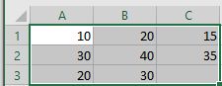
2. 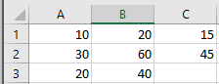

Monotonic interaction

Main effect of A



Monotonic interaction

Main effect of B

5. 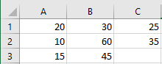

Monotonic interaction

Main effect of A

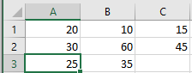

Nonmonotonic interaction

Main effect of B

1. 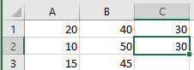

Nonmonotonic interaction

Main effect of A

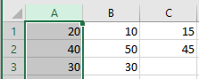

Nonmonotonic interaction

Main effect of B

1. 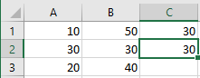

Border between Monotonic and nonmonotonic Interaction

Main effect of A

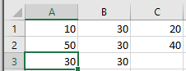

Nonmonotonic Interaction

No Main effect of B

1. 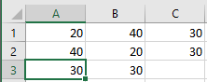

Nonmonotonic Interaction for both

No main effect for A same for B

1. 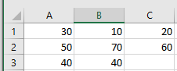

Nonmonotonic Interaction

Main effect of A

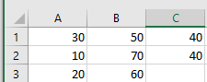

Non-non-Nonmonotonic Interaction

Main effect of B

1. 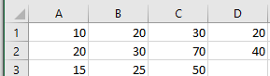

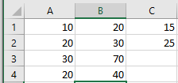

2. A. 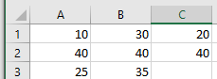

Mean (C=1) -> 25

Mean (C=2) -> 20

A has a main effect of 5

B.